**Report “Lab 9”**

**Anton Tserakhau**

# Oracle Architecture - Partitioning

I have created table with range partition:

CREATE TABLE EMP

(

EMPNO NUMBER (4) NOT NULL,

ENAME VARCHAR2 (10 BYTE),

JOB VARCHAR2 (9 BYTE),

MGR NUMBER (4),

HIREDATE DATE,

SAL NUMBER (7, 2),

COMM NUMBER (7, 2),

DEPTNO NUMBER (2)

)

PARTITION BY RANGE (HIREDATE)

(PARTITION emp_part_1

VALUES LESS THAN (TO_DATE ('01-JAN-1982', 'DD-MON-RR'))

TABLESPACE ts_example_1,

PARTITION emp_part_2

VALUES LESS THAN (TO_DATE ('01-JAN-1983', 'DD-MON-RR'))

TABLESPACE ts_example_2);

## Task 01: CREATE Example of Range partitioning

### Adding Partitions

I have added two partition to table EMP and inserted data into this table:

ALTER TABLE emp ADD PARTITION emp_part_3 VALUES LESS THAN (TO_DATE('01-JAN-1984','DD-MON-RR' )) TABLESPACE ts_example_3;

ALTER TABLE emp ADD PARTITION emp_part_4 VALUES LESS THAN (TO_DATE( '01-JAN-1985','DD-MON-RR')) TABLESPACE ts_example_4;

INSERT INTO EMP

(SELECT empno,

ename,

job,

mgr,

TO_DATE (hiredate, 'DD.MM.RR'),

sal,

comm,

deptno

FROM SCOTT.EMP);

COMMIT;

Result table:

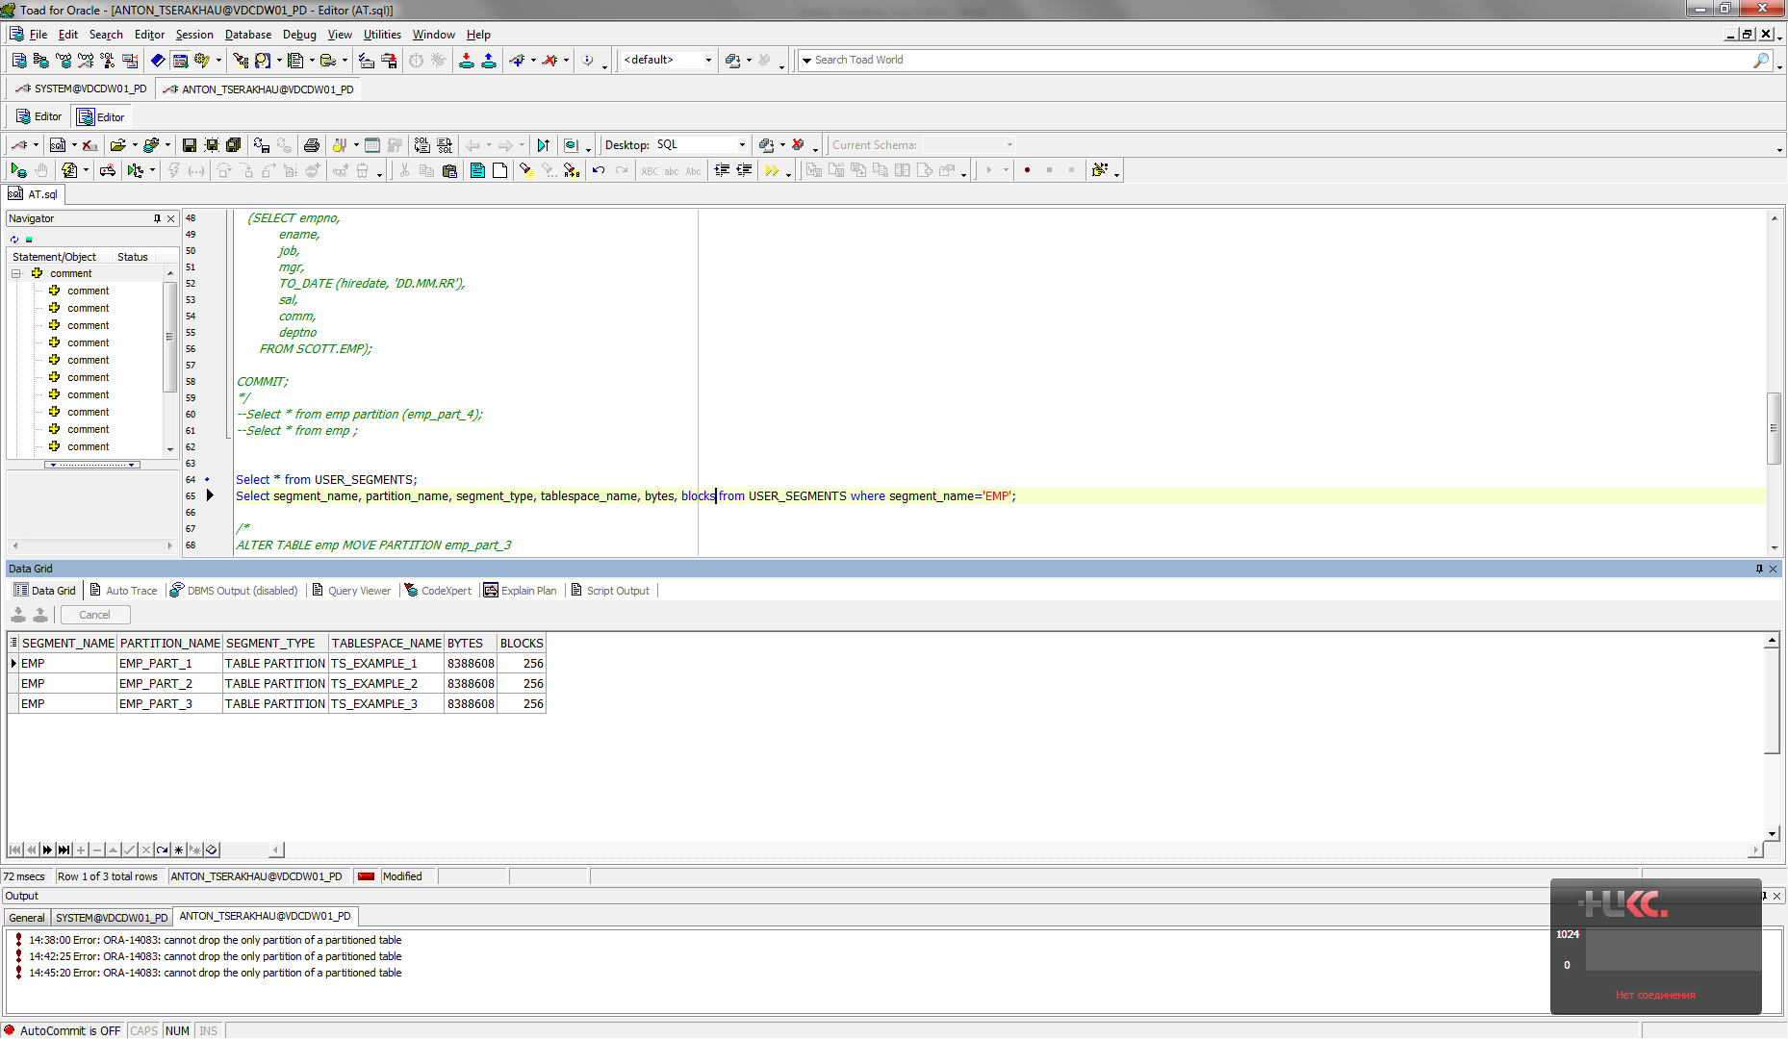

Partition EMP_PART_1:

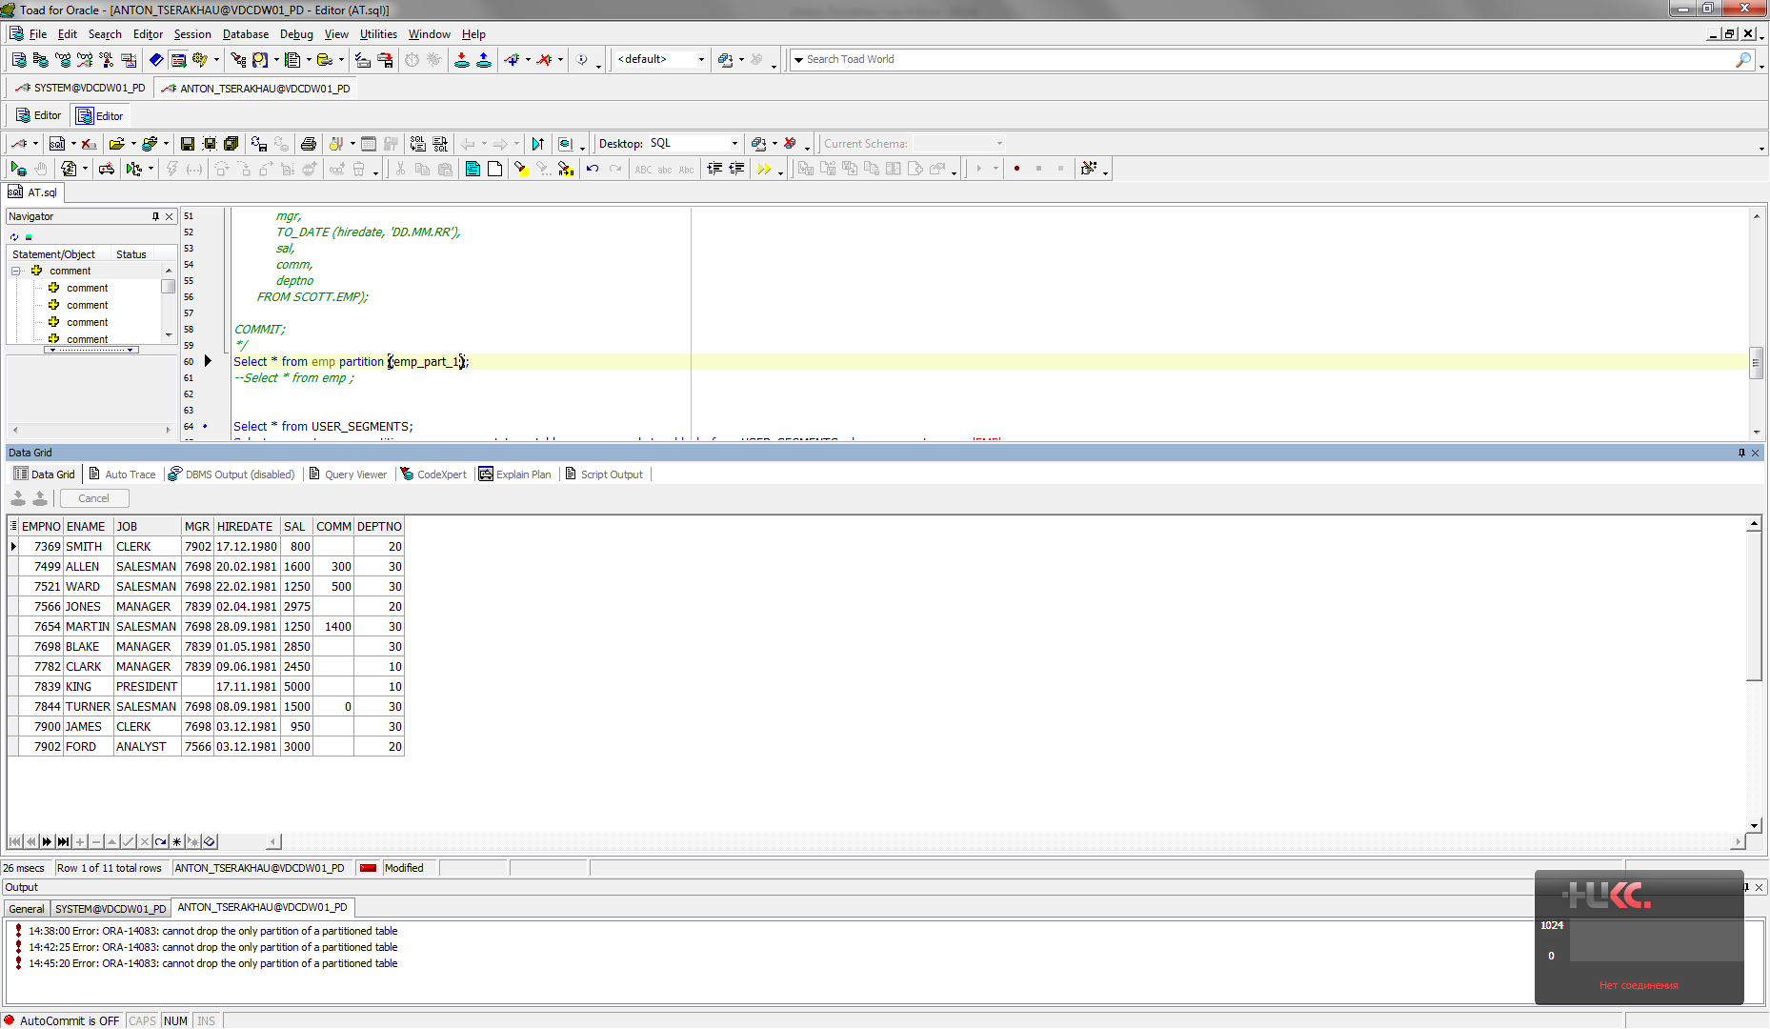

Partition EMP_PART_2:

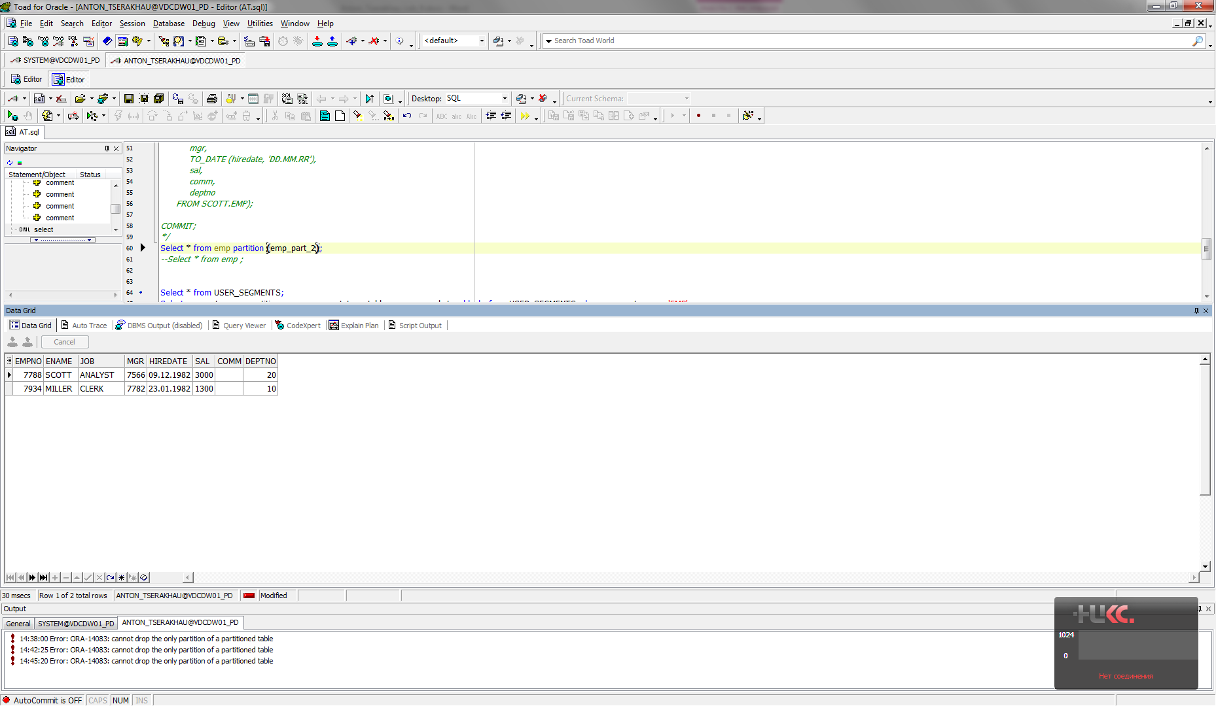

Partition EMP_PART_3:

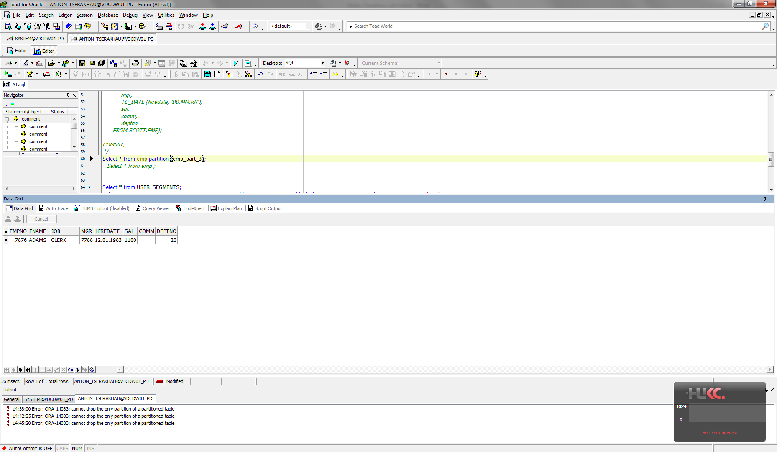

Partition EMP_PART_4:

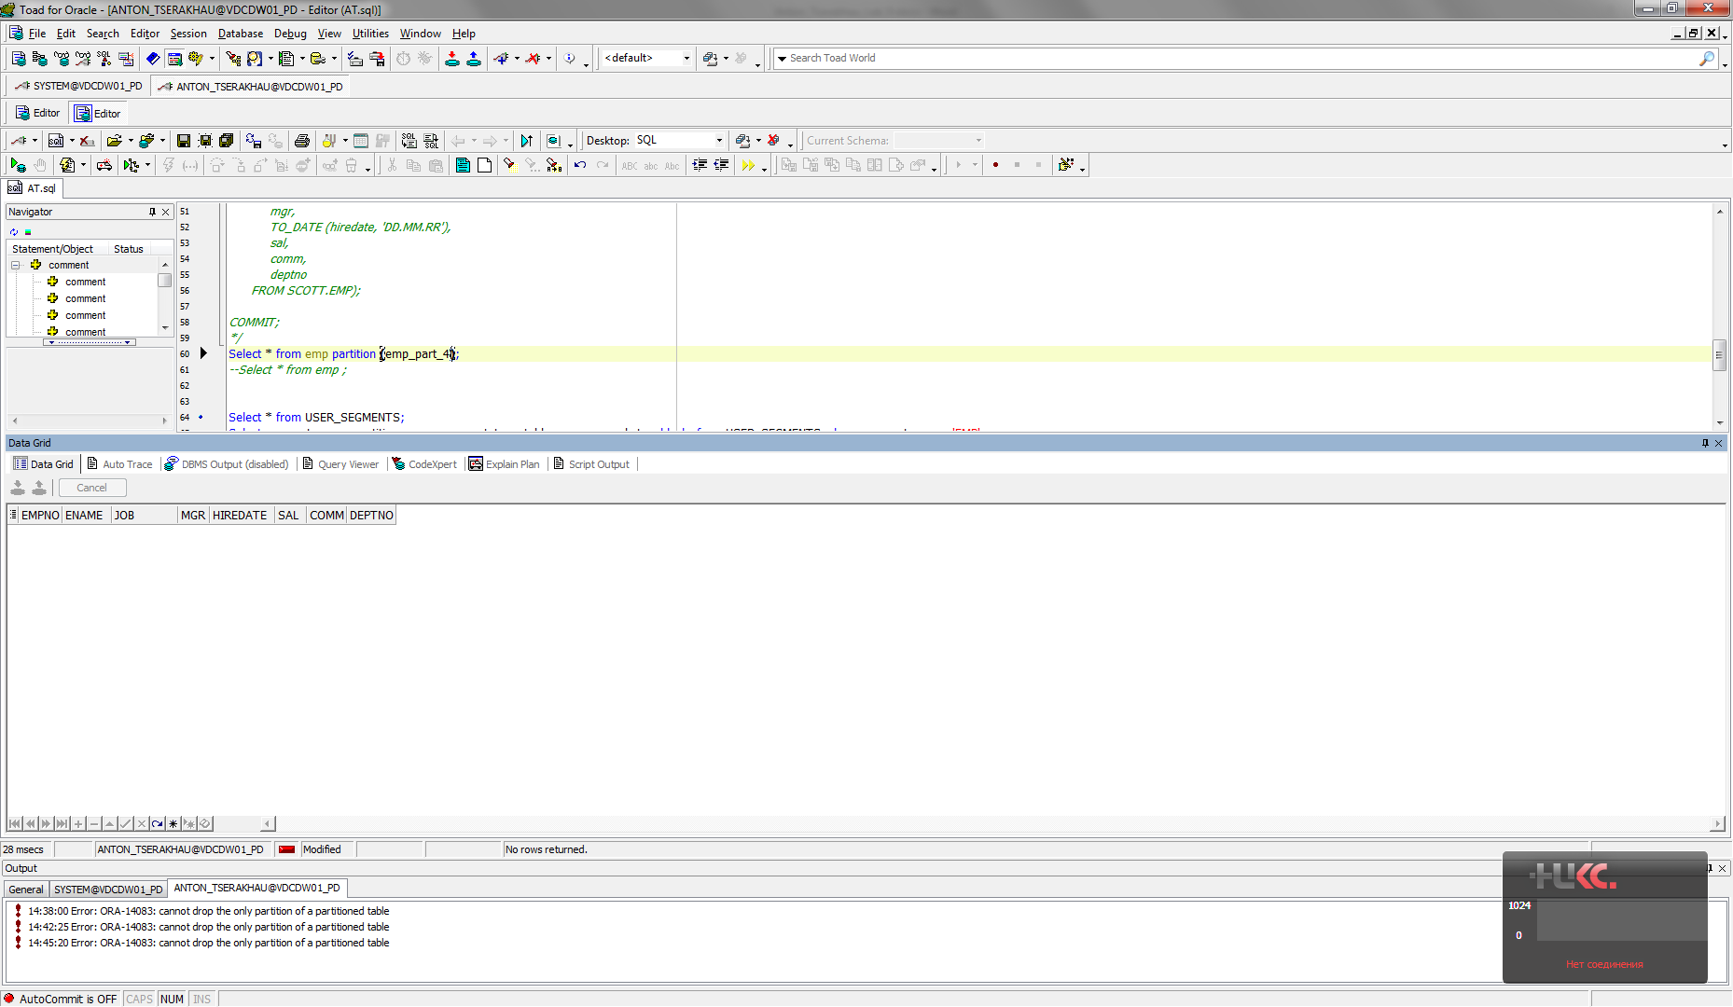

### Moving Partitions

I have moved partition EMP_PART_3 to other tablespace:

ALTER TABLE emp MOVE PARTITION emp_part_3

TABLESPACE tbs_lab;

Result table:

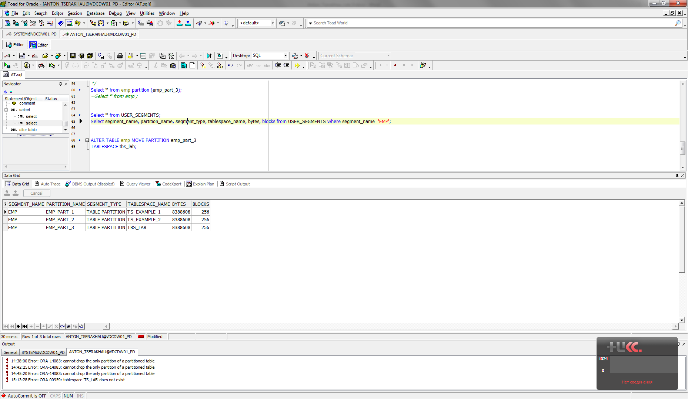

### Splitting Partitions

I have splited one partition EMP_PART_1 to two partitions EMP_PART_1_BEFORE and EMP_PART_1_AFTER:

ALTER TABLE emp SPLIT PARTITION

emp_part_1 at ('01-JAN-1981') INTO ( PARTITION

emp_part_1_before, PARTITION emp_part_1_after);

Result table:

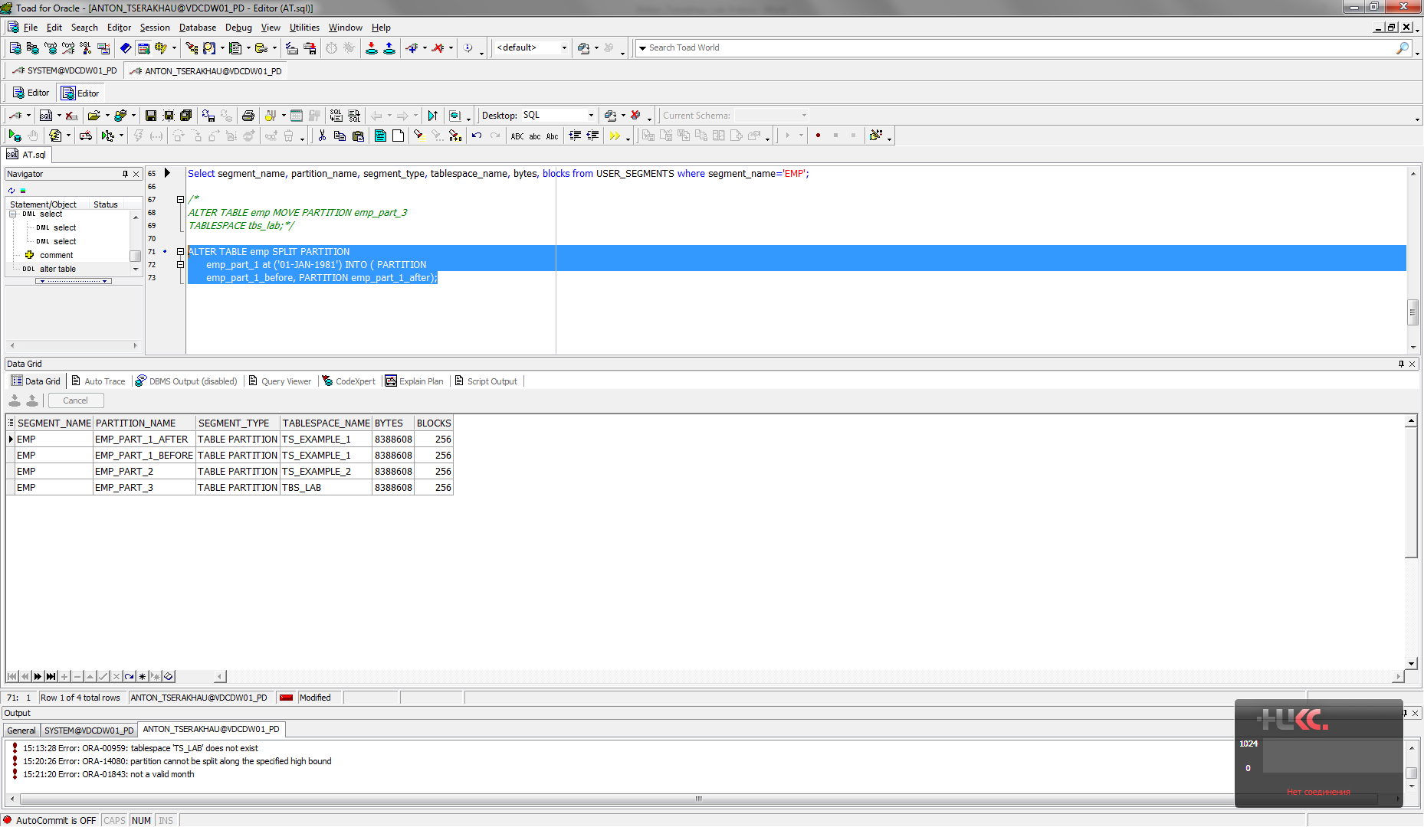

Partition EMP_PART_1_BEFORE:

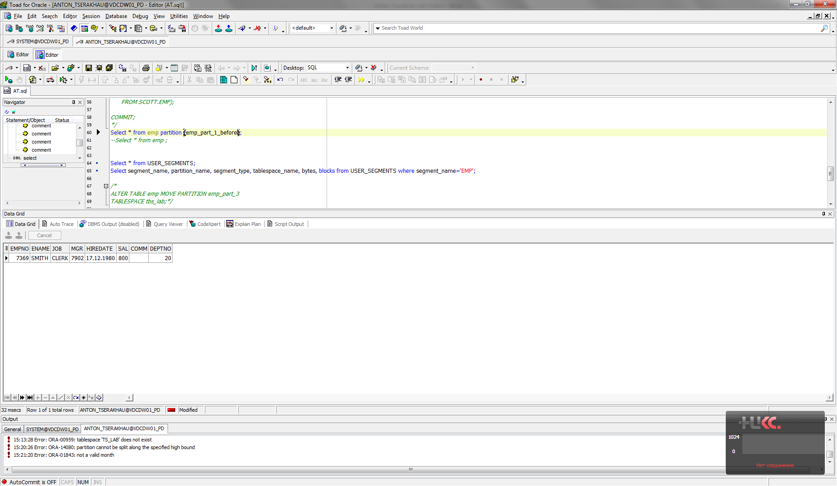

Partition EMP_PART_1_AFTER:

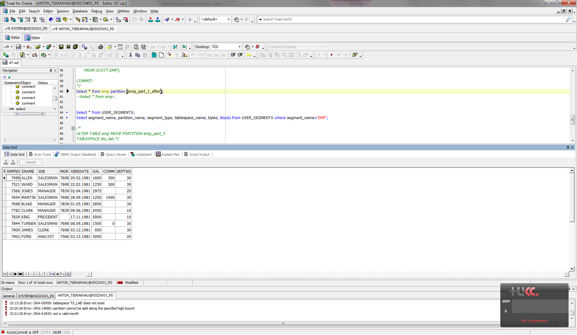

### Merging Partitions

I have merged two partitions EMP_PART_1_BEFORE and EMP_PART_1_AFTER into one partition EMP_PART_1:

ALTER TABLE emp

MERGE PARTITIONS emp_part_1_before, emp_part_1_after

INTO PARTITION emp_part_1;

Result table:

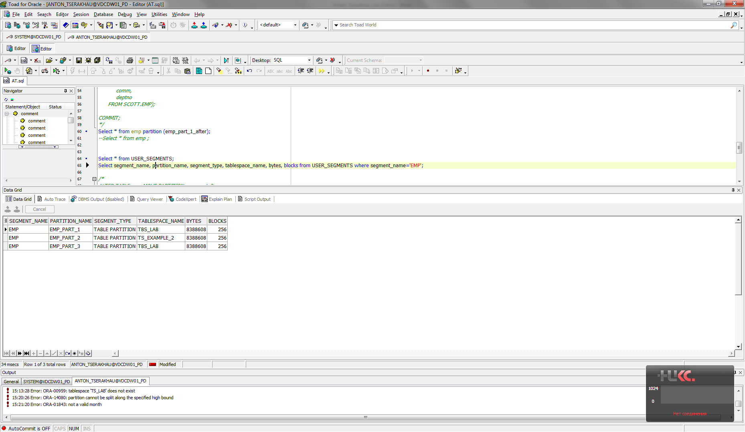

Partition EMP_PART_1:

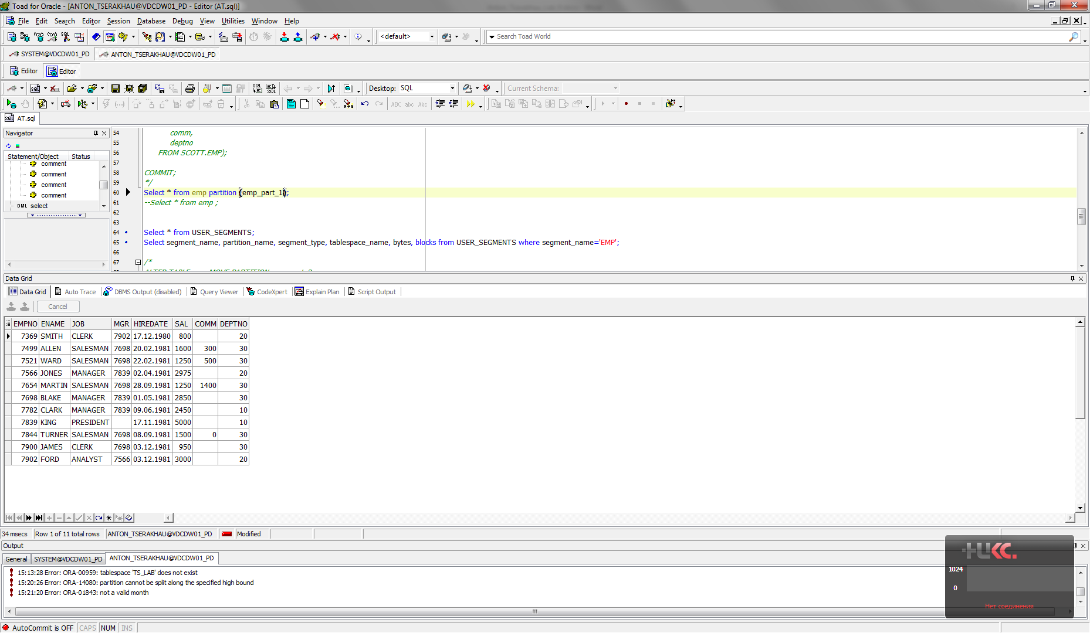

### Truncating Partitions

I have truncated all partitions:

ALTER TABLE emp TRUNCATE PARTITION emp_part_1;

ALTER TABLE emp TRUNCATE PARTITION emp_part_2;

ALTER TABLE emp TRUNCATE PARTITION emp_part_3;

ALTER TABLE emp TRUNCATE PARTITION emp_part_4;

Table EMP(0 rows):

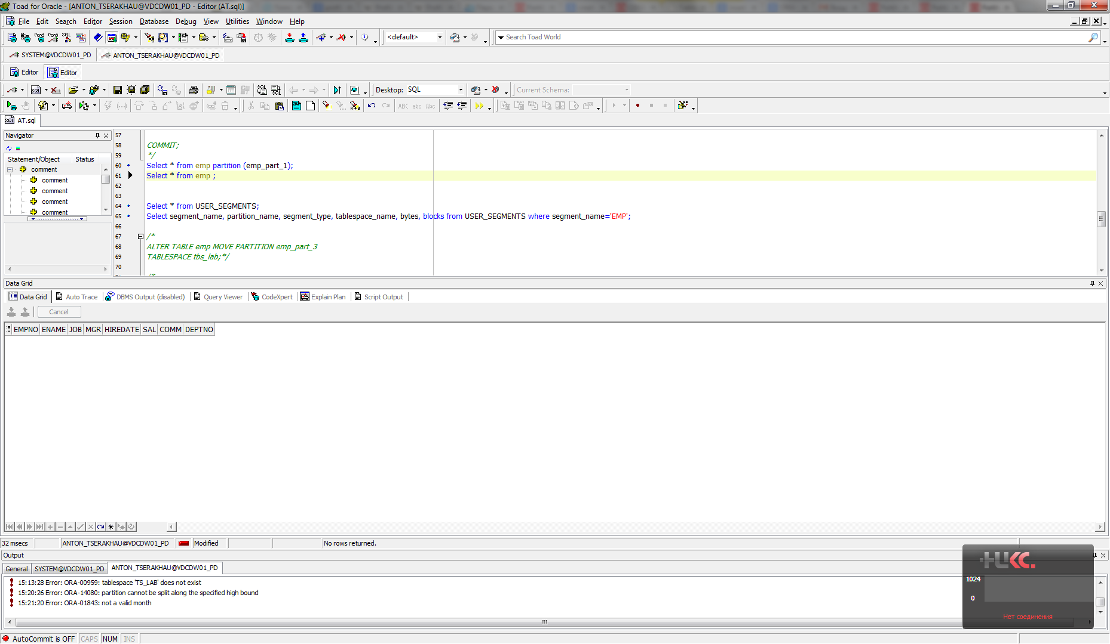

Result table:

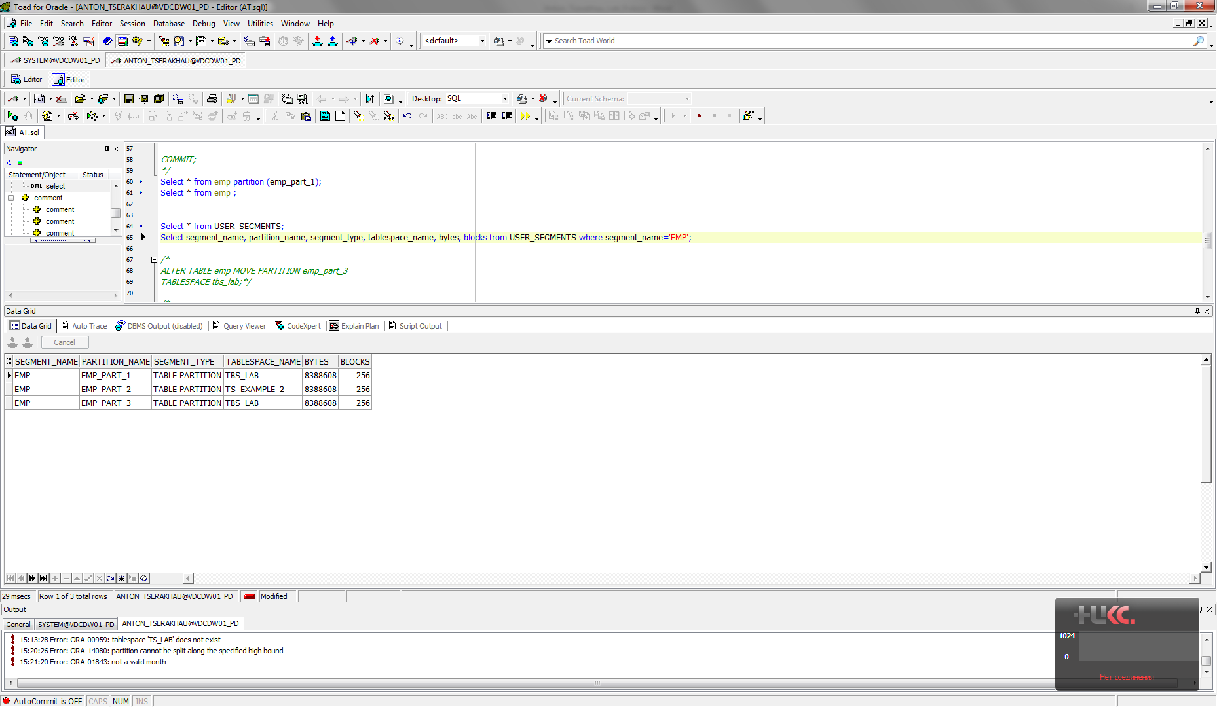

### Dropping Partitions

I have dropped 3 of 4 partitions (1 partition should remain, but at the same time it is empty):

ALTER TABLE emp DROP PARTITION emp_part_1;

ALTER TABLE emp DROP PARTITION emp_part_2;

ALTER TABLE emp DROP PARTITION emp_part_3;

Result table:

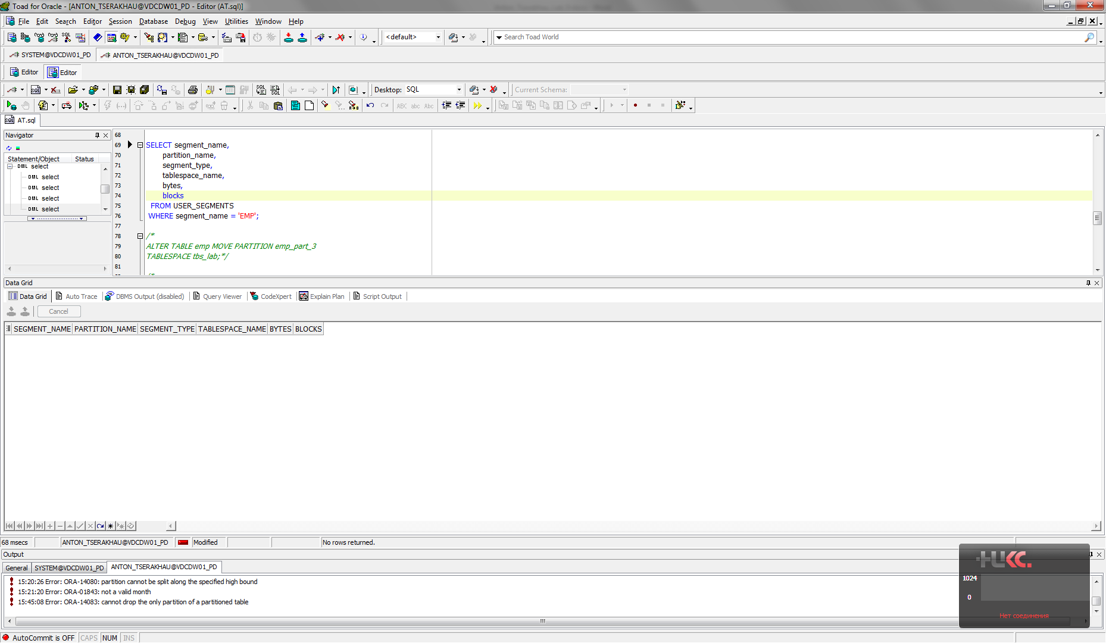

### Coalescing Partitions

I have created table with hash partition and inserted data:

CREATE TABLE DEPT

(DEPTNO NUMBER,

DNAME VARCHAR (32),

LOC VARCHAR (32))

PARTITION BY HASH (DEPTNO)

PARTITIONS 4;

INSERT INTO DEPT

( SELECT * FROM SCOTT.DEPT);

COMMIT;

Table DEPT:

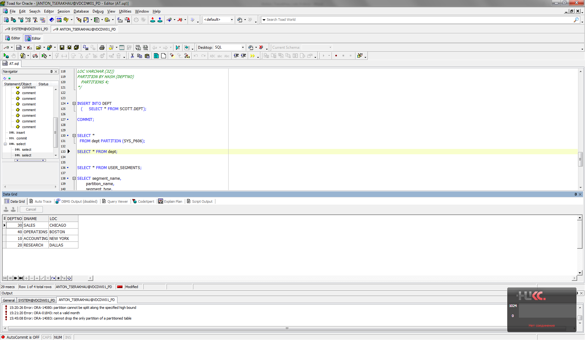

Result table:

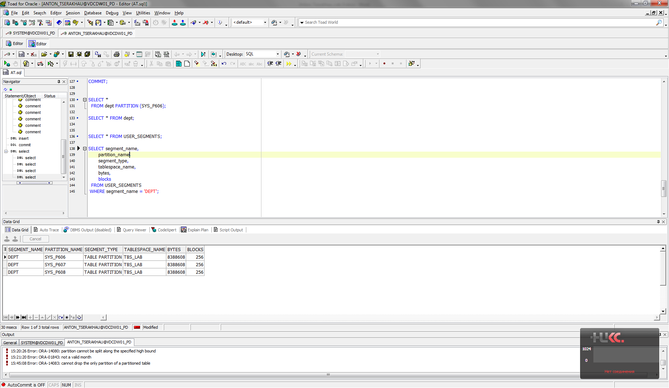

I have reduced partitions into table DEPT (lost only 2 of 4 partitions):

ALTER TABLE dept

COALESCE PARTITION;

ALTER TABLE dept

COALESCE PARTITION;

Table DEPT:

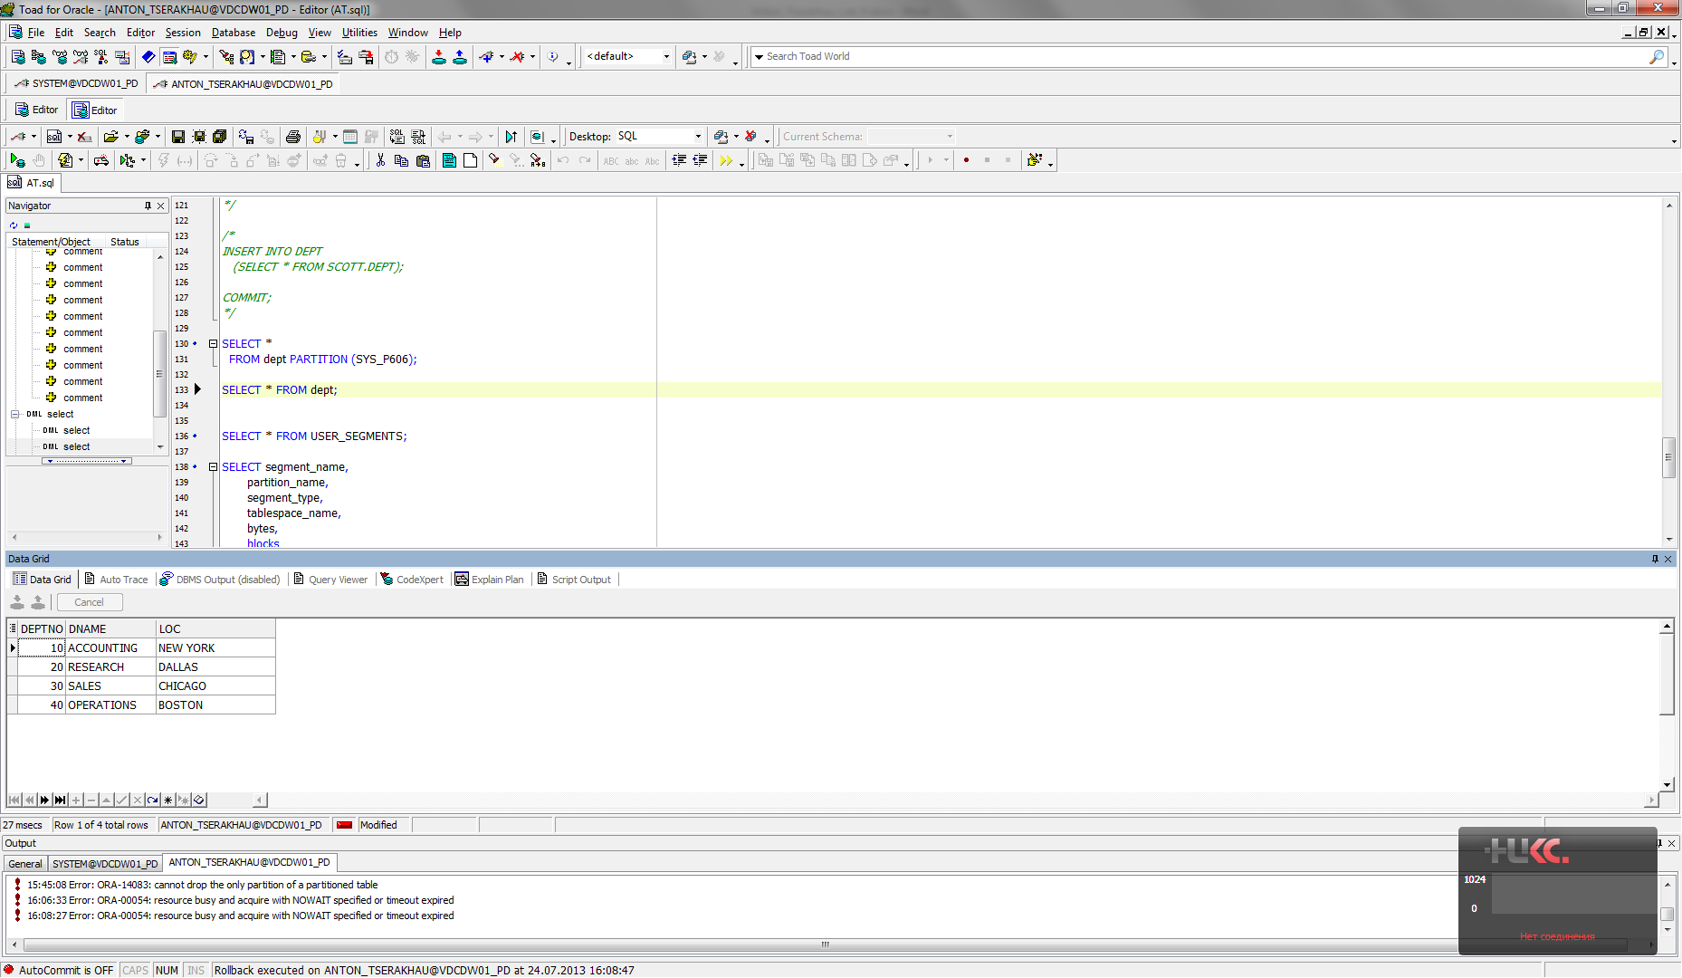

Result table:

